CIR ASTM E2283-08 (2014) report

Excel configuration instructions

Introduction

Goal
As part of the package for the ASTM E2283-08 (2014) report, this document explains how to set up Excel and the Clemex workbook files on a new computer.

Audience
This document is aimed at persons in charge of final deployment of the Clemex CIR ASTM E2283 feature.

Reference Documents
- ASTM International: Standard Practice for Extreme Value Analysis of Nonmetallic Inclusions in Steel and Other Microstructural Features (Link)

Overview
As suggested in section X.1.8.5 of ASTM E2283, the Microsoft Excel SOLVER add-in is used for generating the report.
This document explains how to configure Solver in Excel and how to adapt the Clemex-supplied workbook files for the location of Solver on a particular computer.

Configuring Excel to use Solver

Installing the Solver add-in
In Excel, open the Excel Options box. In Office 2007, this is accessed through the Office button.
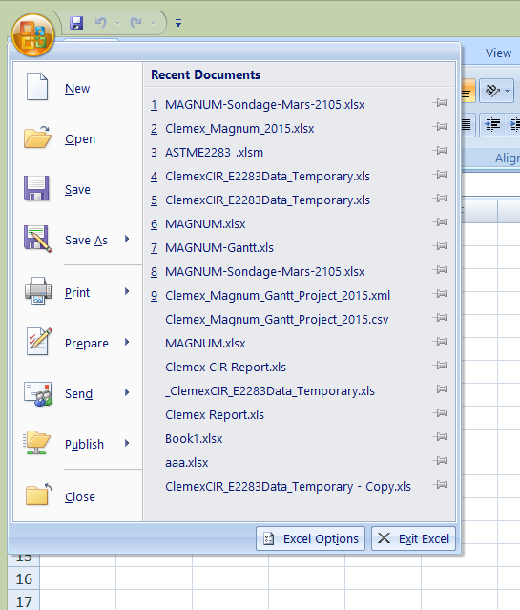

In the left pane, select Add-ins. At the bottom of the window, select Manage Excel Add-ins and click the Go button.
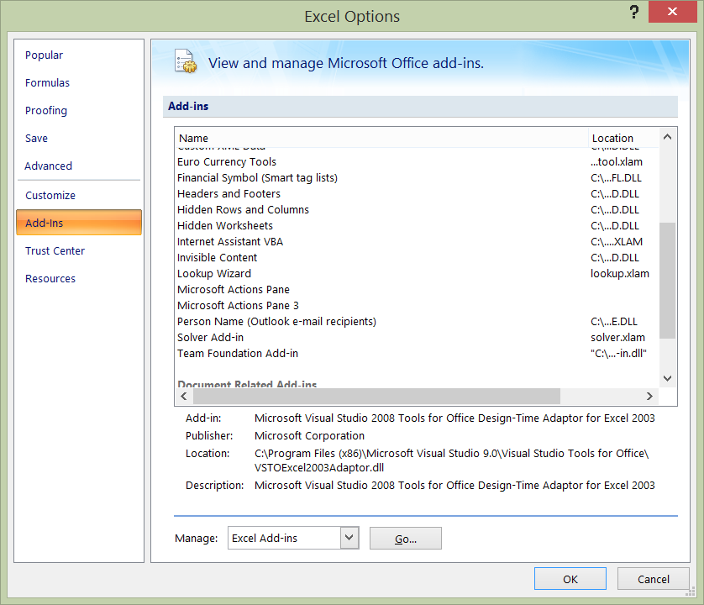

Check the box next to the Solver Add-in.
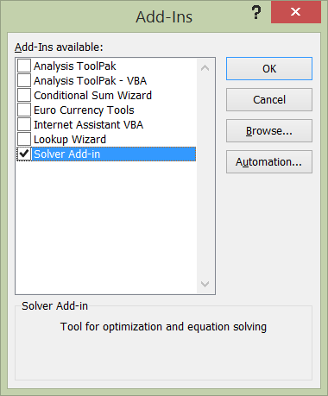

If prompted to install the add-in, select Yes, then wait for it to be activated.
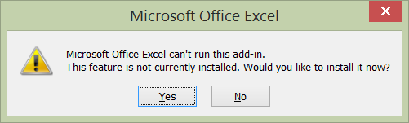
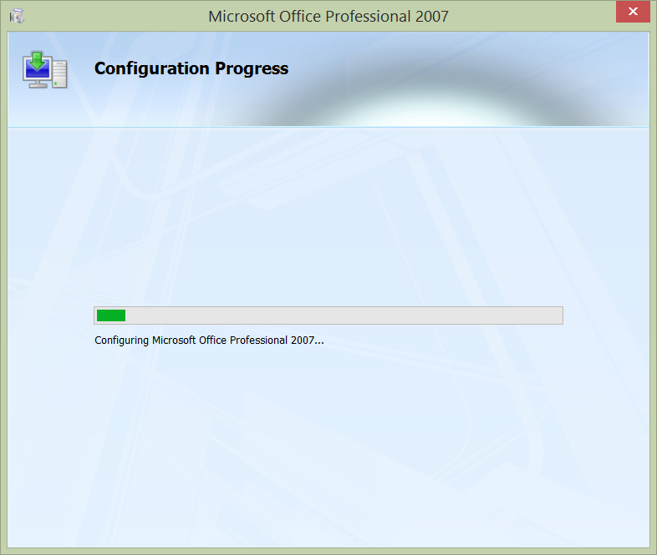

Enabling macros in Excel
In Excel Options, select Trust Center in the left pane and click Trust Center Settings...
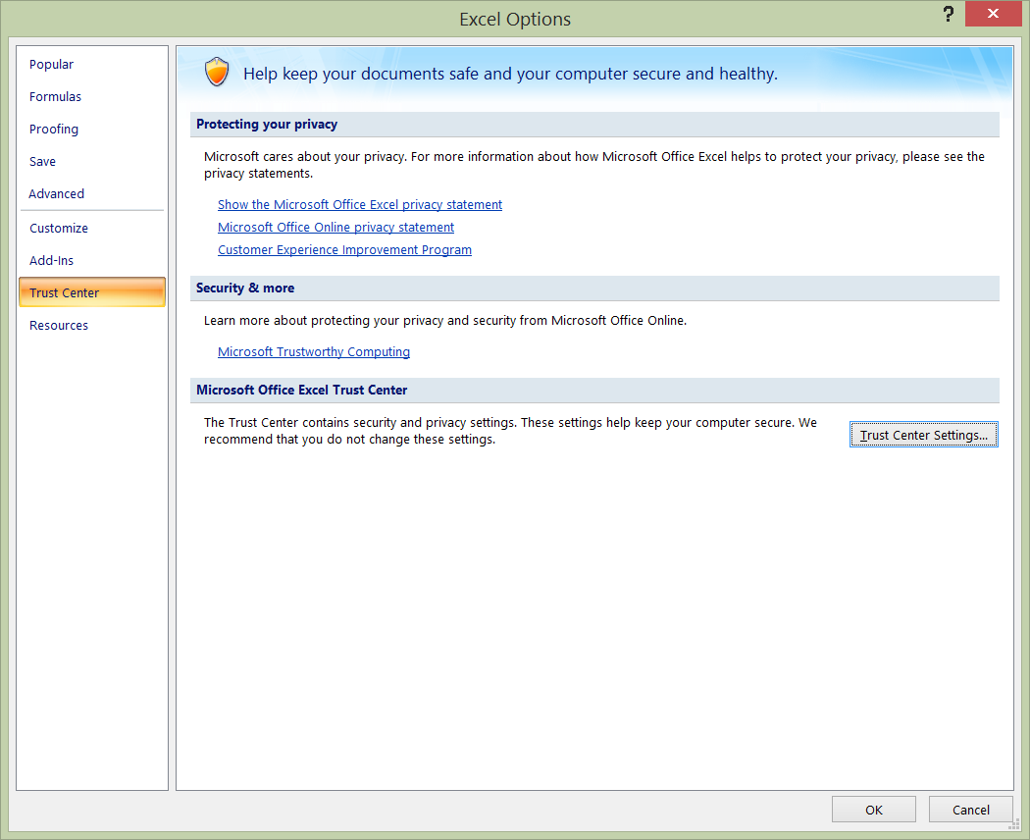

Select options to enable all macros and trust access to the VBA project object model.
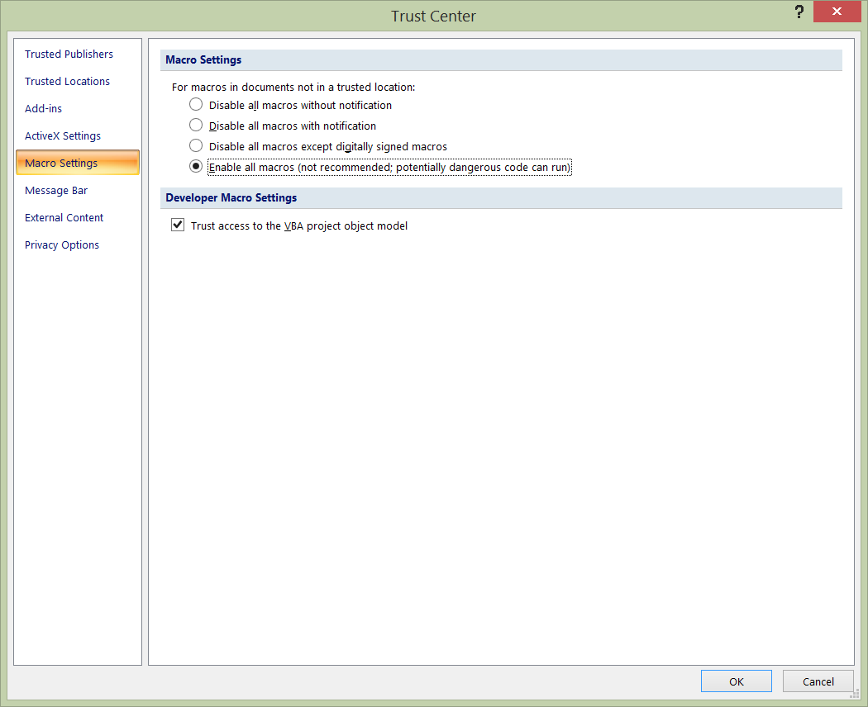

Enabling links to external content in Excel
In the Trust Center, select External Content in the left pane.
Turn on data connections and automatic updates.
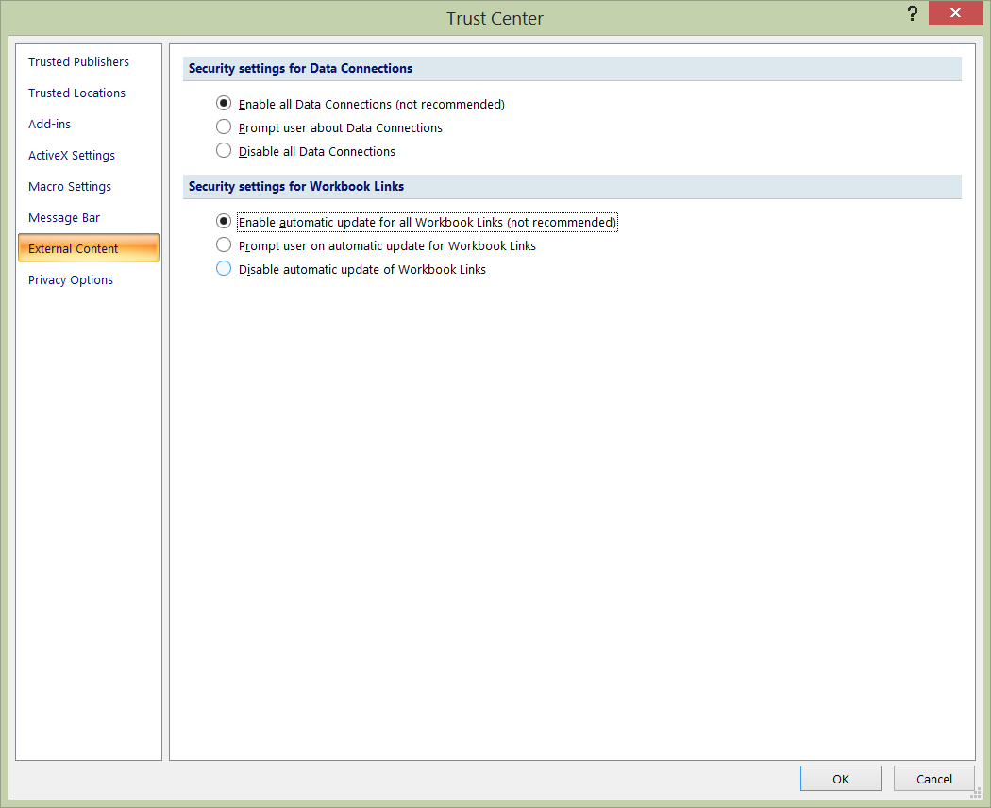

Altering the Clemex workbook to reference Solver
The Clemex-supplied workbook for the ASTM E2283-08 (2014) report contains macros which reference the Solver add-in. On some systems, it will be necessary to adjust the reference to Solver according to the installed version of Office.

Locating the Solver add-in
Open Windows Explorer and navigate to the root of the system drive (normally C:). Use the search box to perform a search for SOLVER.XLAM.
After several seconds, you should see one or more entries for the SOLVER.XLAM file. Select the one located in C:\Program Files or C:\Program Files (x86).
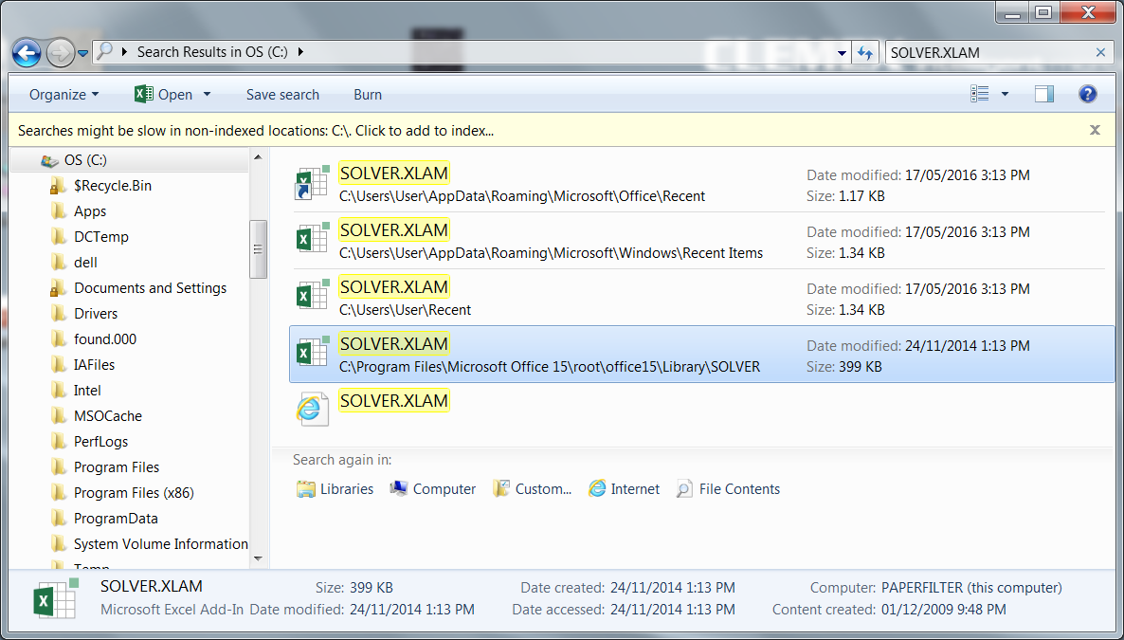

Jot down the precise location of the file. It will be used in a later step.

Opening the workbook
In Windows Explorer, double-click on this file (notice the .XLSM extension) :
C:\IAFiles\Template\Clemex_CIR_ASTM-E2283_Template_.xlsm
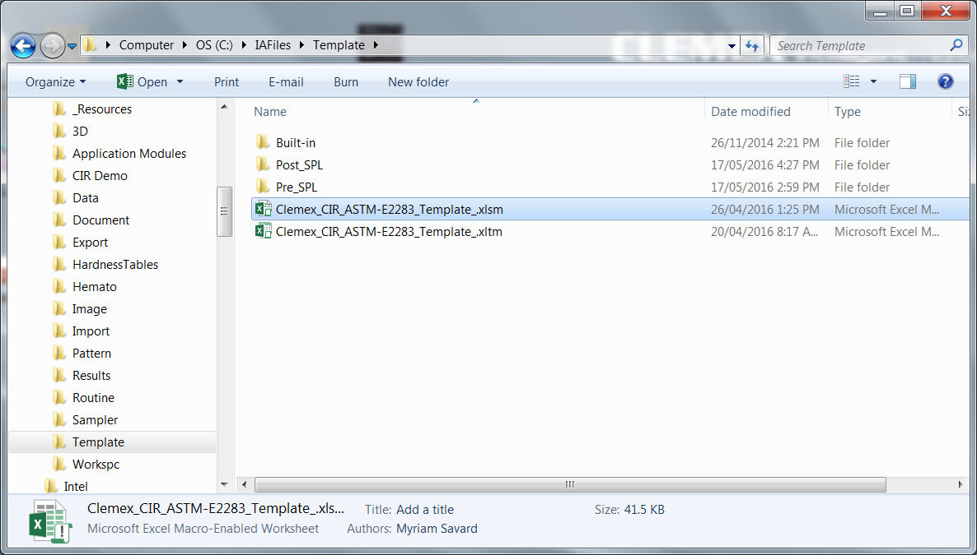

Excel should open the file. If you are prompted about external sources, select Don't Update.
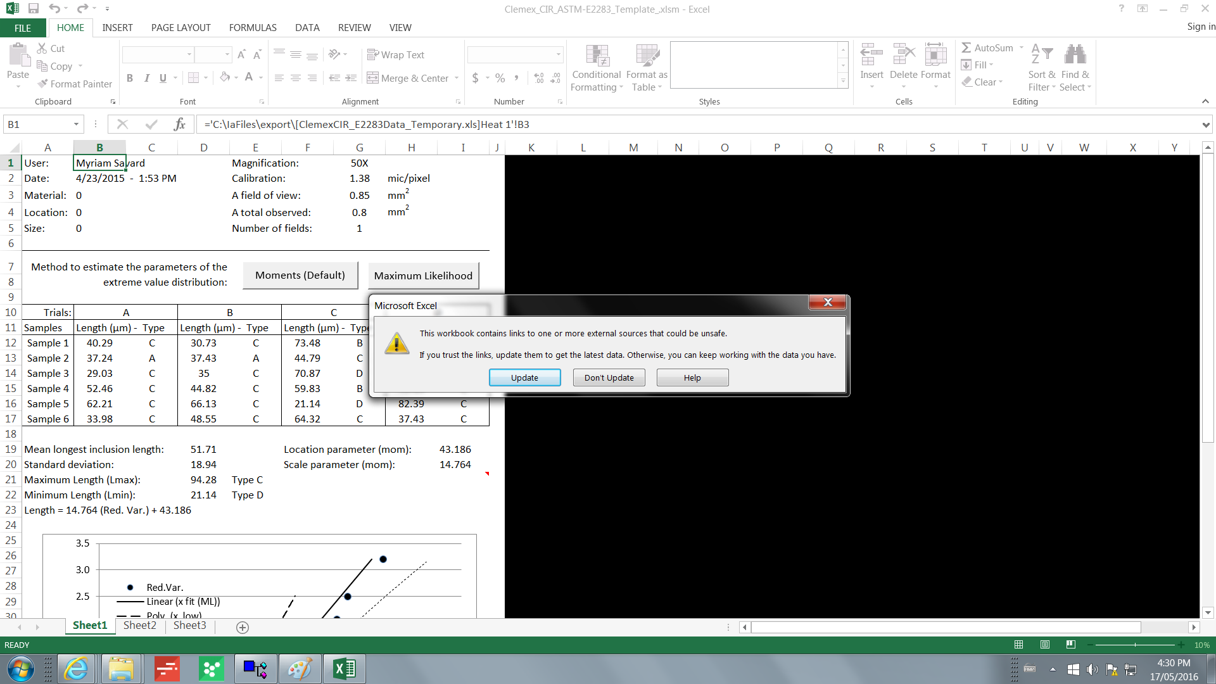

Accessing the VBA window
From the View area of the Ribbon, select View Macros... Alternately, you can press the Alt-F8 keys to access the Macro window.
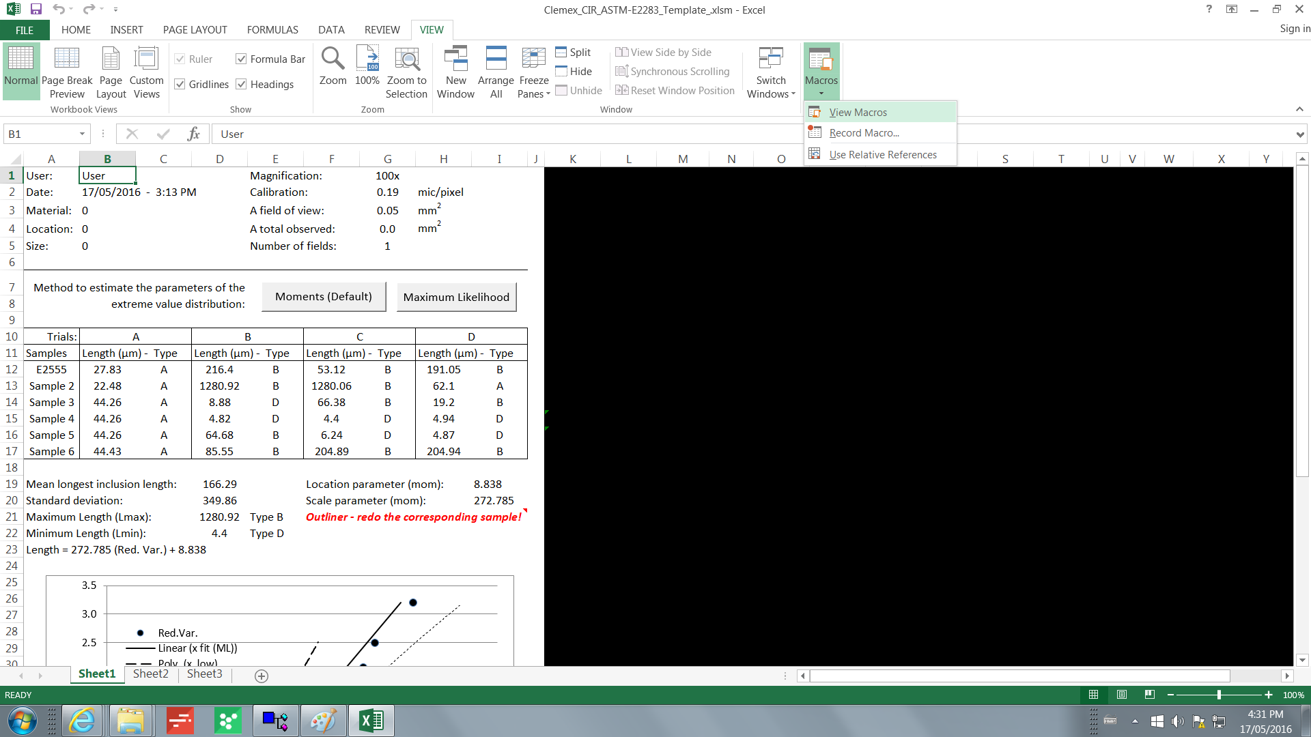

Click on Solver_Maximize_In_ML and press the Edit button.
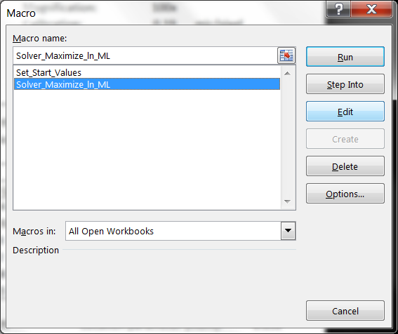

This should open the Visual Basic for Applications (VBA) window.
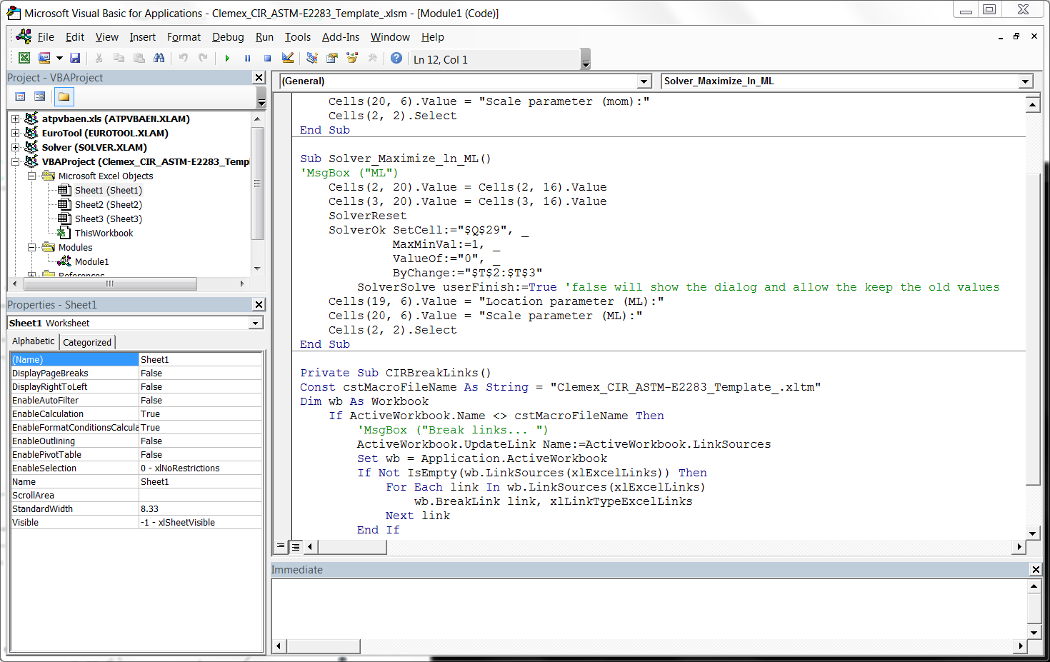

Updating the references
in the VBA window, open the Tools menu and select References.
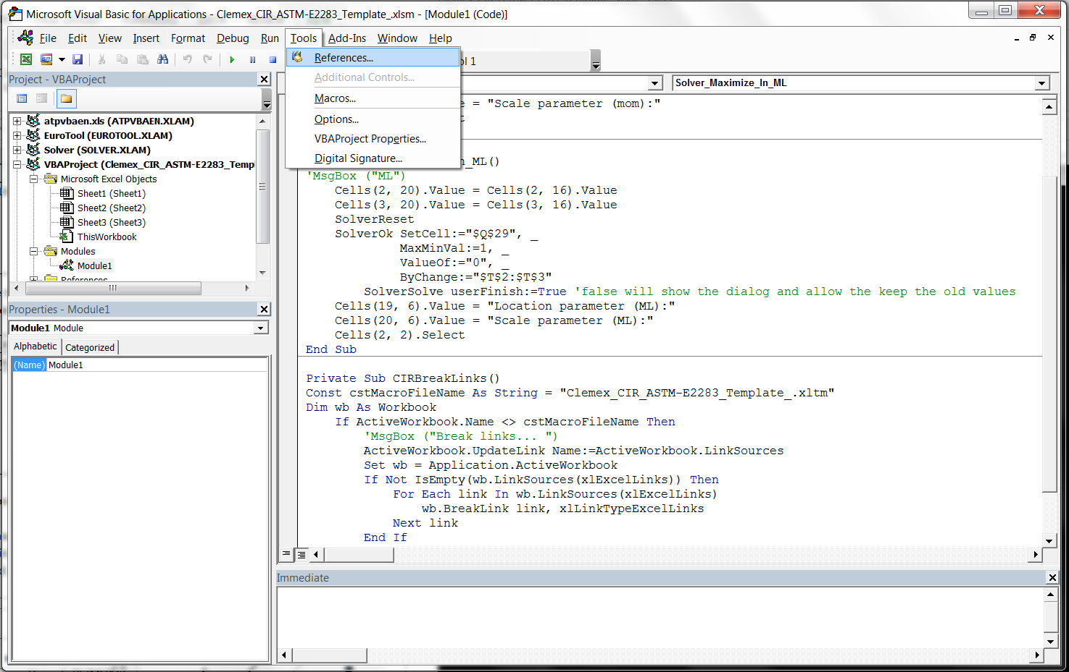

You should see the References window.
Locate the entry for Solver in the list of references. A reference to Solver should appear in the list, with or without the word "MISSING". Select it and click the Browse button.
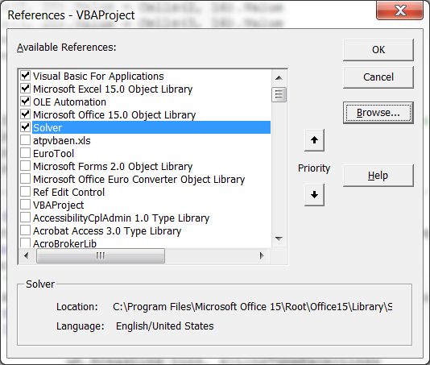

Select the file type "Excel files" in the lower right. Browse to the location for Solver.XLAM, obtained on page 9 .
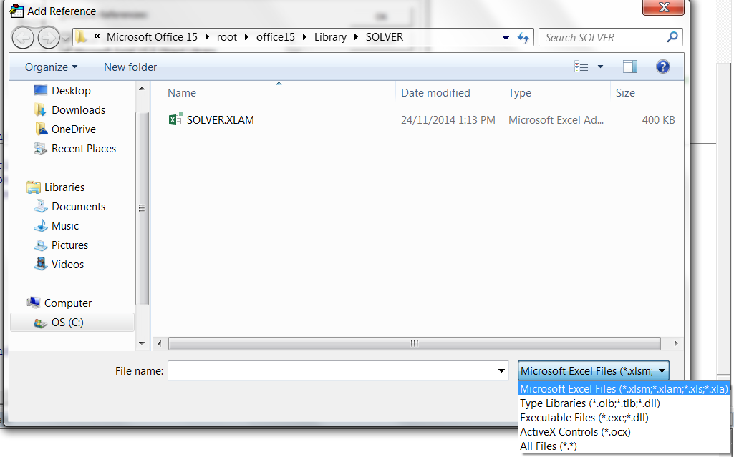
Click the Open button.

Click OK to close the References window. Close the VBA window, then close the workbook completely. If asked whether to save changes, select Yes or Save.

